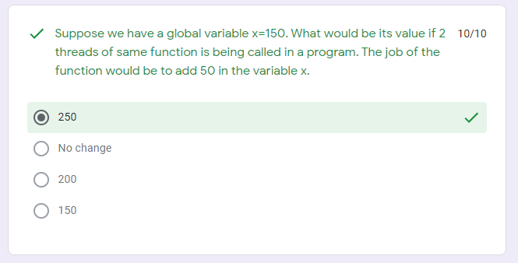

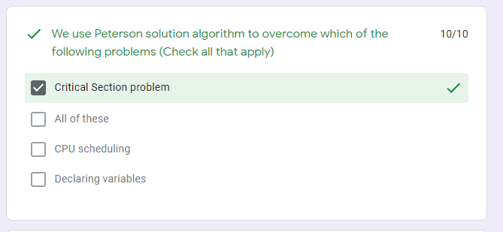

Question: Implement Test and set instruction algorithm. Upload only one screenshot (only image file accepted) of the code as well as the output of the program combined. Any plagiarism will be marked as 0 (Both sides).

Ans:

